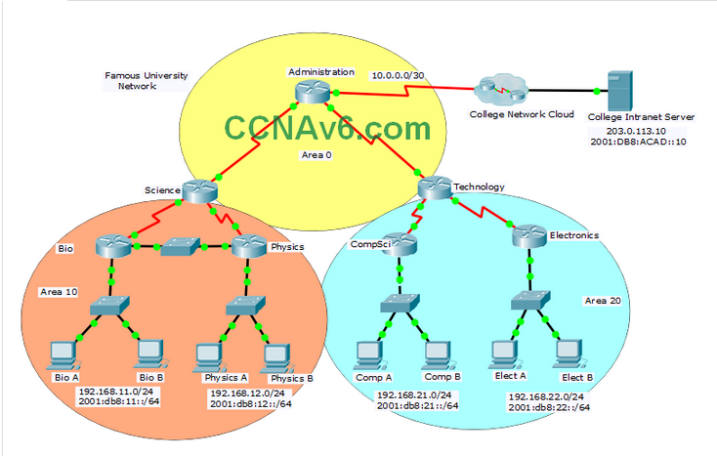

**A few things to keep in mind while completing this activity:**

1. Do not use the browser **Back**button or close or reload any exam windows during the exam.
2. Do not close Packet Tracer when you are done. It will close automatically.
3. Click the **Submit Assessment**button in the browser window to submit your work.

**Introduction**

In this practice skills assessment, you will configure the Famous University network with OSPF routing. The network is configured with both IPv4 and IPv6 on all devices. This will allow you to implement routing in both OSPFv2 and OSPFv3. In addition, you will configure both versions of OSPF in multiple areas.  For a full list of tasks, see below.

**You are not required to configure the following:**

* The network switches
* The network hosts
* The College Intranet Server
* The College Network Cloud

**All IOS device configurations should be completed from a direct terminal connection to the device console.**

You will practice and be assessed on the following skills:

* Configuration of IPv4 and IPv6 default routes
* Configuration of OSPFv2 in a single area
* Configuration of OSPFv2 in multiple areas
* Configuration of OSPFv3 in a single area
* Configuration of OSPFv3 in multiple areas
* Customization of OSPFv2 and OSPFv3 settings
  + Interface Bandwidth
  + OSPF Priority
  + OSPF timer settings
  + Passive interfaces

You will configure specific devices as follows:

**Router Administration:**

* IPv4 and IPv6 default route configuration
* OSPFv2 and OSPFv3 Area 0 configuration
* Interface bandwidth configuration
* OSPFv2 and OSPFv3 router ID configuration
* Distribution of default routes
* Auto-cost reference bandwidth configuration for OSPFv2 and OSPFv3

**Router Science:**

* OSPFv2 and OSPFv3 Area 0 configuration
* OSPFv2 and OSPFv3 Area 10 configuration
* Interface bandwidth configuration
* OSPFv2 and OSPFv3 router ID configuration
* Auto-cost reference bandwidth configuration for OSPFv2 and OSPFv3

**Router Bio:**

* OSPFv2 and OSPFv3 Area 10 configuration
* OSPFv2 and OSPFv3 router ID configuration
* Auto-cost reference bandwidth configuration for OSPFv2 and OSPFv3
* OSPFv2 and OSPFv3 interface priority configuration
* OSPFv2 and OSPFv3 hello and dead timer configuration
* OSPFv2 and OSPFv3 passive interface configuration

**Router Physics**

* OSPFv2 and OSPFv3 Area 10 configuration
* OSPFv2 and OSPFv3 router ID configuration
* Auto-cost reference bandwidth configuration for OSPFv2 and OSPFv3
* OSPFv2 and OSPFv3 interface priority configuration
* OSPFv2 and OSPFv3 hello and dead timer configuration
* OSPFv2 and OSPFv3 passive interface configuration

**Router Technology:**

* OSPFv2 and OSPFv3 Area 0 configuration
* OSPFv2 and OSPFv3 Area 20 configuration
* Interface bandwidth configuration
* OSPFv2 and OSPFv3 router ID configuration
* Auto-cost reference bandwidth configuration for OSPFv2 and OSPFv3

**Router CompSci:**

* OSPFv2 and OSPFv3 Area 20 configuration
* OSPFv2 and OSPFv3 router ID configuration
* Auto-cost reference bandwidth configuration for OSPFv2 and OSPFv3
* OSPFv2 and OSPFv3 interface priority configuration
* OSPFv2 and OSPFv3 hello and dead timer configuration
* OSPFv2 and OSPFv3 passive interface configuration

**Router Electronics:**

* OSPFv2 and OSPFv3 Area 20 configuration
* OSPFv2 and OSPFv3 router ID configuration
* Auto-cost reference bandwidth configuration for OSPFv2 and OSPFv3
* OSPFv2 and OSPFv3 interface priority configuration
* OSPFv2 and OSPFv3 hello and dead timer configuration
* OSPFv2 and OSPFv3 passive interface configuration

**Addressing Table**

Use the following addresses to configure the network. Some addresses are preconfigured on devices that you are not required to configure, and are provided for reference purposes only.

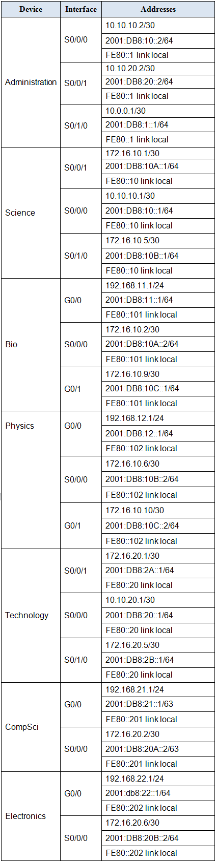

**Host Address Table**

The addresses of the PC and server hosts are provided for connectivity testing purposes. All addressing is preconfigured.

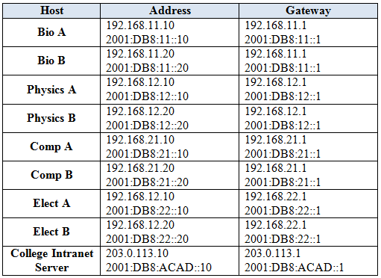

**Instructions**

**Step1: Configure default static routes on the Administration router.**

Configure IPv4 and IPv6 default static routes on **Administration**. Use the exit interface value in your configuration.

**Step 2: Configure single-area OSPFv2**

On the **Administration**, **Science**, and **Technology** routers, configure single-area OSPFv2 in **Area 0**.

a. Use a process ID of **10**for **all** OSPFv2 processes.

b. Activate routing for the appropriate networks. Use inverse masks that specify **only** addresses within the networks.

c. Specify a bandwidth value that matches the clock speed of the interfaces of **Administration** for interfaces of **all**devices that are configured in Area 0.

d. Set the router IDs as follows:

Administration: **10.20.0.0**  
Science: **10.0.0.0**  
Technology:**20.0.0.0**

**Step 3: Configure single-area OSPFv3.**

On the**Administration**, **Science**, and **Technology** routers configure single-area OSPFv3 in **Area 0**.

a. Use a process ID of **10**for **all** OSPFv3 processes.

b. Activate routing for the appropriate networks.

c. Set the router IDs as follows:

Administration:**10.20.0.0**Science: **10.0.0.0**  
Technology: **20.0.0.0**

**Step 4: Configure OSPFv2 in multiple areas.**

Configure the routers that have **all** interfaces in Areas 10 and 20 with OSPFv2.

a. Use a process ID of **10** for all OSPF processes.

b. Activate routing for the appropriate networks. Use inverse masks that specify **only** addresses within the networks. After this step is completed, hosts on all LANs should be able to communicate with each other over IPv4.

c. Set the router IDs as follows:

Bio:**10.1.1.1**Physics: **10.2.2.2**CompSci: **20.1.1.1**Electronics: **20.2.2.2**

**Step 5: Configure OSPFv3 in multiple areas.**

Configure the routers that have **all** interfaces in Areas 10 and 20 with OSPFv3.

a. Enable the routers to route IPv6.

b. Use a process ID of **10** for all OSPF processes.

c. Activate routing for the appropriate networks. After this step is completed, hosts on all LANs should be able to communicate with each other over IPv6.

d. Set the router IDs as follows:

Bio:**10.1.1.1**Physics: **10.2.2.2**CompSci: **20.1.1.1**Electronics: **20.2.2.2**

**Step 6: Customize OSPFv2.**

Customize OSPFv2 operation as follows:

a. For the multiaccess network connected between the **Bio**and **Physics** routers, configure priorities so that **Bio** will become the DR and **Physics** will be the BDR. Use priority values of**255** and **200**.

b. Configure the interfaces on all routers that are attached to LANs with hosts to **not**send OSPFv2 traffic into the LAN.

c. Enable all routers to automatically and accurately calculate costs for routes that include 1Gbps Ethernet networks by changing the reference bandwidth.

d. Configure OSPFv2 so that the default routes that are configured on **Administration**are automatically distributed to all routers in the network.

e. Adjust the OSPFv2 timers on the Ethernet link between **Bio**and **Physics** as follows:

Hello: **5** seconds  
Dead: **20** seconds

**Step 7: Customize OSPFv3.**

Customize OSPFv3 operation as follows:

a. For the multiaccess network connected between the **Bio**and **Physics** routers configure priorities so that **Bio** will become the DR and **Physics** will be the BDR. Use priority values of **255** and **200**.

b. Configure the interfaces on all routers that are attached to LANs with hosts to **not**send OSPFv3 traffic into the LAN.

c. Enable all routers to automatically and accurately calculate costs for routes that include 1Gbps Ethernet networks by changing the reference bandwidth.

d. Configure OSPFv3 so that the default routes that are configured on **Administration**are automatically distributed to all routers in the network.

e. Explicitly configure the OSPFv3 timers on the Ethernet link between **Bio** and **Physics** as follows:

Hello: **5** seconds  
Dead: **20** seconds

### Router: Administration / HQ / Town-HalL

en

conf terminal

ip route 0.0.0.0 0.0.0.0 s0/1/0

ipv6 unicast-routing

ipv6 route ::/0 s0/1/0

router ospf 10

network 10.10.10.0 0.0.0.3 area 0

network 10.10.20.0 0.0.0.3 area 0

router-id 10.20.0.0

do clear ip ospf process

yes

exit

int s0/0/0

bandwidth 128

int s0/0/1

bandwidth 128

exit

int s0/0/0

ipv6 ospf 10 area 0

int s0/0/1

ipv6 ospf 10 area 0

exit

Ipv6 router ospf 10

router-id 10.20.0.0

do clear ipv6 ospf process

yes

exit

router ospf 10

auto-cost reference-bandwidth 1000

exit

router ospf 10

default-information originate

exit

ipv6 router ospf 10

default-information originate

exit

ipv6 router ospf 10

auto-cost reference-bandwidth 1000

### Router: Science / London / Schools

EN

conf ter

router ospf 10

network 10.10.10.0 0.0.0.3 area 0

network 172.16.10.0 0.0.0.3 area 10

network 172.16.10.4 0.0.0.3 area 10

router-id 10.0.0.0

do clear ip ospf process

yes

exit

ipv6 unicast-routing

Int s0/0/0

Ipv6 ospf 10 area 0

exit

Int s0/0/1

Ipv6 ospf 10 area 10

exit

Int s0/1/0

Ipv6 ospf 10 area 10

exit

int s0/0/0

bandwidth 128

exit

ipv6 router ospf 10

router-id 10.0.0.0

do clear ipv6 ospf process

yes

exit

ipv6 router ospf 10

auto-cost reference-bandwidth 1000

exit

router ospf 10

auto-cost reference-bandwidth 1000

### Router: Technology / Dubai / Safety

en

conf ter

Router ospf 10

network 10.10.20.0 0.0.0.3 area 0

network 172.16.20.0 0.0.0.3 area 20

network 172.16.20.4 0.0.0.3 area 20

router-id 20.0.0.0

do clear ip ospf process

yes

exit

ipv6 unicast-routing

Int s0/0/0

Ipv6 ospf 10 area 0

exit

Int s0/0/1

Ipv6 ospf 10 area 20

exit

Int s0/1/0

Ipv6 ospf 10 area 20

exit

int s0/0/0

bandwidth 128

exit

Ipv6 router ospf 10

router-id 20.0.0.0

do clear ipv6 ospf process

yes

exit

router ospf 10

auto-cost reference-bandwidth 1000

exit

ipv6 router ospf 10

auto-cost reference-bandwidth 1000

### Router: Bio / West / Primary

en

conf ter

router ospf 10

network 172.16.10.0 0.0.0.3 area 10

network 192.168.11.0 0.0.0.255 area 10

network 172.16.10.8 0.0.0.3 area 10

router-id 10.1.1.1

do clear ip ospf process

yes

exit

ipv6 unicast-routing

int s0/0/0

ipv6 ospf 10 area 10

exit

int g0/0

ipv6 ospf 10 area 10

exit

int g0/1

ipv6 ospf 10 area 10

exit

ipv6 router ospf 10

router-id 10.1.1.1

do clear ipv6 ospf process

yes

exit

int g0/1

ip ospf priority 255

exit

router ospf 10

passive-interface g0/0

exit

router ospf 10

auto-cost reference-bandwidth 1000

exit

int g0/1

ip ospf hello-interval 5

ip ospf dead-interval 20

exit

int g0/1

ipv6 ospf priority 255

exit

ipv6 router ospf 10

passive-interface g0/0

exit

int g0/1

ipv6 ospf hello-interval 5

ipv6 ospf dead-interval 20

exit

ipv6 router ospf 10

auto-cost reference-bandwidth 1000

### Router: Physics / East / Secondary

en

conf ter

Router ospf 10

network 172.16.10.4 0.0.0.3 area 10

network 172.16.10.8 0.0.0.3 area 10

network 192.168.12.0 0.0.0.255 area 10

router-id 10.2.2.2

do clear ip ospf process

yes

exit

ipv6 unicast-routing

int s0/0/0

ipv6 ospf 10 area 10

exit

int g0/0

ipv6 ospf 10 area 10

exit

int g0/1

ipv6 ospf 10 area 10

exit

ipv6 router ospf 10

router-id 10.2.2.2

do clear ip ospf process

yes

exit

int g0/1

ip ospf priority 200

exit

router ospf 10

passive-interface g0/0

exit

router ospf 10

auto-cost reference-bandwidth 1000

exit

int g0/1

ip ospf hello-interval 5

ip ospf dead-interval 20

exit

int g0/1

ipv6 ospf priority 200

exit

ipv6 router ospf 10

passive-interface g0/0

exit

int g0/1

ipv6 ospf hello-interval 5

ipv6 ospf dead-interval 20

exit

ipv6 router ospf 10

auto-cost reference-bandwidth 1000

### Router: CompSci / Central / Police

en

conf ter

Router ospf 10

network 172.16.20.0 0.0.0.3 area 20

network 192.168.21.0 0.0.0.255 area 20

router-id 20.1.1.1

do clear ip ospf process

yes

exit

ipv6 unicast-routing

int s0/0/0

ipv6 ospf 10 area 20

exit

int g0/0

ipv6 ospf 10 area 20

exit

ipv6 router ospf 10

router-id 20.1.1.1

do clear ipv6 ospf process

yes

exit

router ospf 10

passive-interface g0/0

exit

ipv6 router ospf 10

passive-interface g0/0

exit

router ospf 10

auto-cost reference-bandwidth 1000

exit

ipv6 router ospf 10

auto-cost reference-bandwidth 1000

### Router: Electronics / Remote / Fire

en

conf ter

Router ospf 10

network 172.16.20.4 0.0.0.3 area 20

network 192.168.22.0 0.0.0.255 area 20

router-id 20.2.2.2

do clear ip ospf process

yes

exit

ipv6 unicast-routing

int s0/0/0

ipv6 ospf 10 area 20

exit

int g0/0

ipv6 ospf 10 area 20

exit

ipv6 router ospf 10

router-id 20.2.2.2

do clear ipv6 ospf process

yes

exit

router ospf 10

passive-interface g0/0

exit

ipv6 router ospf 10

passive-interface g0/0

exit

router ospf 10

auto-cost reference-bandwidth 1000

exit

ipv6 router ospf 10

auto-cost reference-bandwidth 1000